Simple Predicate

✅ What Is a Simple Predicate?
# Source: AI Source: Provided by: [Data Path: Persons Table -> ID Column: 1, Name_En Column: Motasem Essam] -> From: [ChatGPT] on [8/4/2025]
A Simple Predicate is the main verb or verb phrase in a sentence.
It tells what the subject does or what happens to the subject — without including modifiers, objects, or complements.

🔸 Key Features:
# Source: AI Source: Provided by: [Data Path: Persons Table -> ID Column: 1, Name_En Column: Motasem Essam] -> From: [ChatGPT] on [8/4/2025]
- It includes only the main verb or verb phrase.
- It does not include adverbs, objects, or any modifiers.
- It may be:
  - A single verb (e.g., "ran")
  - A verb phrase (e.g., "has gone", "will be coming")

🔸 Examples:
# Source: AI Source: Provided by: [Data Path: Persons Table -> ID Column: 1, Name_En Column: Motasem Essam] -> From: [ChatGPT] on [8/4/2025]
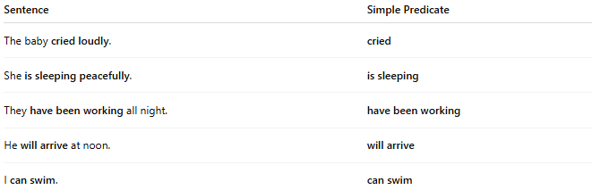
Sentence | Simple Predicate
The baby cried loudly. | cried
She is sleeping peacefully. | is sleeping
They have been working all night. | have been working
He will arrive at noon. | will arrive
I can swim. | can swim

🔸 Compare with Complete Predicate:
# Source: AI Source: Provided by: [Data Path: Persons Table -> ID Column: 1, Name_En Column: Motasem Essam] -> From: [ChatGPT] on [8/4/2025]
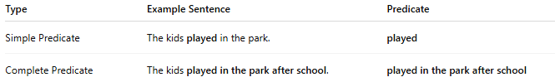
Type | Example Sentence | Predicate
Simple Predicate | The kids played in the park. | played
Complete Predicate | The kids played in the park after school. | played in the park after school

